Abstract
Internet of Things (IoT) environments generate distributed and privacy-sensitive network data, while many edge devices have limited processing power and weak built-in security. Conventional cloud-based intrusion detection requires raw telemetry transfer, which introduces privacy leakage, communication cost, and dependence on a central service. This report proposes PRIVATE SHIELD, a unified federated intelligence framework for IoT threat detection. The framework keeps raw traffic at each client, trains lightweight local detection models, protects shared updates through differential privacy and gradient clipping, filters suspicious updates before aggregation, assigns reputation scores to clients, and presents human-readable alerts through a security operations center dashboard. The proposed design addresses four connected weaknesses found in existing research: gradient leakage, poisoning attacks, free-rider participation, and limited operational explainability. The report defines the architecture, workflow, main algorithms, implementation modules, threat model, and evaluation plan for an academic prototype. Expected results include lower raw-data exposure, improved tolerance to malicious clients, reduced communication compared with centralized telemetry collection, and faster interpretation of security events.
Index Terms—Federated learning, Internet of Things, intrusion detection, differential privacy, poisoning defense, free-rider detection, explainable security.
I. INTRODUCTION
IoT devices are now used in homes, healthcare, industrial monitoring, transportation, and smart infrastructure. Their wide deployment increases the attack surface because many devices run with limited memory, low-power processors, outdated firmware, or weak authentication. Botnets, denial-of-service traffic, scanning activity, and malicious device behavior can therefore spread quickly across connected environments.
A centralized intrusion detection system (IDS) normally transfers device telemetry to a cloud server for training and analysis. Although this approach simplifies management, it exposes sensitive traffic, consumes bandwidth, and creates a single point of failure. Federated learning (FL) offers an alternative by sending a model to clients, training locally, and sharing only model updates. However, FL does not automatically guarantee privacy or security. Gradients can leak information, malicious clients can poison the shared model, and free-riders can receive benefits without contributing reliable updates [7]–[12].
PRIVATE SHIELD is proposed as an edge-focused system that connects privacy, adversarial robustness, client reliability, and operational explanation in one workflow. The system is intended for an academic prototype rather than a production security appliance, but its modular structure supports controlled experiments and future extension.
II. PROBLEM STATEMENT AND RESEARCH MOTIVATION
The reviewed studies show that recent FL-based IDS methods improve distributed learning under heterogeneous IoT data [1]–[6]. Privacy-preserving methods add differential privacy, secure aggregation, or execution proofs [7], [8], [10], while robust aggregation methods identify suspicious model updates [6], [9], [10]. Separate studies investigate free-rider behavior [11], [12]. The central problem is that these mechanisms are commonly evaluated as isolated defenses. A practical IoT security workflow needs them to operate together without creating excessive computation or communication overhead.
A. Primary Problems
The proposed work focuses on six connected problems: (1) raw telemetry exposure in centralized IDS, (2) privacy leakage from shared gradients, (3) model poisoning by malicious clients, (4) unreliable or free-rider participation, (5) non-independent and imbalanced traffic across devices, and (6) weak translation of technical model outputs into understandable security alerts.
B. Design Objectives
The system is designed to keep raw records local, use lightweight models suitable for simulated edge clients, add controlled privacy noise, reject abnormal updates before aggregation, maintain a simple reputation score for each client, support non-IID experiments, and provide a live dashboard that explains why an event is considered suspicious. These objectives directly convert the identified research gaps into implementable software modules.
III. PROPOSED SYSTEM ARCHITECTURE
The architecture contains distributed IoT clients, a federated coordination server, an adversarial validation layer, and an SOC interface. Each client collects or receives local traffic records, preprocesses them, and trains a lightweight binary or multi-class classifier. Raw data never leaves the client. After local training, the client clips its model update, adds differential privacy noise, and sends the protected update with limited metadata to the server.
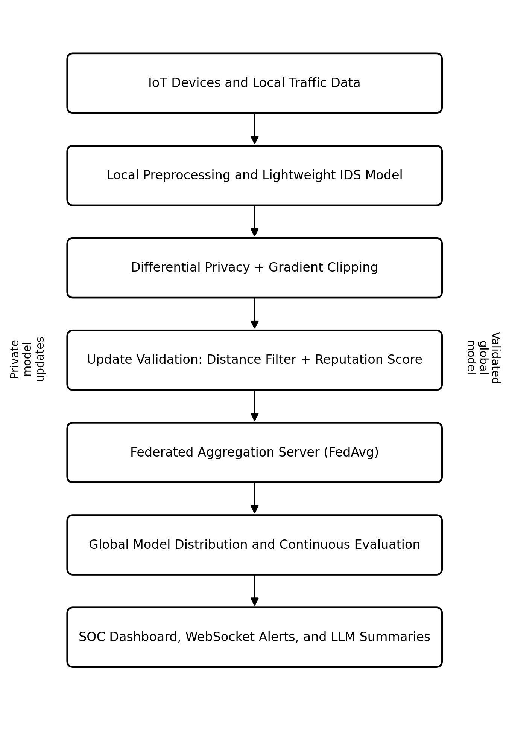
Fig. 1. Proposed PRIVATE SHIELD architecture and processing flow.
Before aggregation, the server compares each received update with a trusted reference such as the current global model, a robust center, or the median update. Euclidean distance provides a simple anomaly score for the initial prototype. Updates that exceed a configurable threshold are rejected or assigned a reduced weight. A reputation component records accepted, rejected, missing, and unstable participation so that consistently unreliable clients have less influence in future rounds.
Accepted updates are combined using Federated Averaging (FedAvg). The updated global model is returned to participating clients for the next round. Training statistics, alert counts, suspected attacks, client status, and model performance are transmitted through WebSockets to a React-based dashboard. An optional large language model module receives structured event summaries rather than raw private traffic and produces short forensic explanations for administrators.
IV. DETAILED PROPOSED METHODOLOGY
A. Local Data Preparation and Detection Model
Each simulated IoT client stores its local traffic in a separate partition. Features may include packet rate, byte count, protocol or port information, connection frequency, message interval, device type, and selected sensor values. Categorical fields are encoded and numerical features are scaled using parameters learned from the local training split. To represent real IoT diversity, client partitions will be intentionally non-IID: some clients will contain different device behaviors, normal ranges, or attack proportions.
The baseline classifier will be a small multilayer perceptron or another lightweight model that can be trained quickly on CPU. A centralized model will first establish an upper-bound reference. The same architecture will then be trained through FL so that differences in accuracy, recall, latency, and communication can be measured fairly.
B. Federated Training Workflow
At round t, the server selects available clients and sends the current global parameters. Client k trains for a small number of local epochs using its private dataset and returns an update. FedAvg calculates a weighted average based on the number of local training samples. Local epochs and batch size will remain small to avoid unrealistic edge computation. The server records round duration, selected clients, received updates, rejected updates, and global validation results.
C. Differential Privacy and Gradient Clipping
Differential privacy is introduced through Opacus or an equivalent privacy engine. Per-sample gradients are clipped to a maximum norm C, which limits the influence of a single record. Gaussian noise is then added before the optimizer step or before update sharing. The privacy budget will be reported using epsilon and delta. Several privacy settings will be tested because stronger noise may improve privacy but reduce minority-attack recall. This privacy-utility trade-off is a central experimental question.
D. Poisoned-Update Detection
A malicious or compromised client may scale, reverse, randomize, or deliberately manipulate model parameters. PRIVATE SHIELD applies a lightweight validation stage before aggregation. For each update, the server computes its L2 distance from the current global model or from a robust reference formed by the received updates. A threshold based on the median distance and median absolute deviation can adapt to round-to-round changes. Clearly abnormal updates are rejected; borderline updates are down-weighted. The prototype will compare this method with ordinary FedAvg to measure the improvement under poisoning.
E. Reputation-Based Client Validation
Each client begins with a neutral reputation value. The score increases after timely and statistically consistent contributions and decreases after missing rounds, submitting malformed data, or repeatedly generating rejected updates. Reputation is not used as the only evidence of an attack; instead, it adjusts selection priority or aggregation weight. A recovery rule prevents one accidental failure from permanently excluding a client. This component provides a practical response to free-rider and unreliable participation concerns [11], [12].
F. SOC Dashboard and LLM-Assisted Explanation
The dashboard will display system state, device participation, message rate, current round, detected attack type, alert severity, global model metrics, privacy settings, and update-rejection events. WebSockets enable live status updates without repeatedly refreshing the page. For each important alert, structured evidence such as abnormal packet rate, suspicious port activity, update distance, and client reputation is passed to an explanation module. The generated summary should state what happened, why it was flagged, and what an administrator should inspect next. Raw packet payloads and local training records will not be sent to the language model.
V. THREAT MODEL AND SECURITY ASSUMPTIONS
The prototype assumes an honest-but-curious coordination server that follows the FL protocol but should not learn individual raw records. A subset of clients may be malicious, compromised, inactive, or selfish. Attacks considered in the first evaluation include denial-of-service traffic, port scanning, Mirai-style connection bursts, label flipping, model replacement, update scaling, random update injection, and free-rider behavior. The framework does not claim complete protection against collusion, advanced adaptive attackers, or a fully compromised server. These limitations are kept explicit so the experimental results remain realistic.
Secure transport, authentication, and access control are required in a deployment. For the academic prototype, MQTT and HTTP/WebSocket services will run in a controlled environment. Tokens or client identifiers can be used to prevent accidental unauthorized participation. Differential privacy protects individual contribution patterns, while update filtering protects model integrity; the two mechanisms solve different risks and are therefore combined.

VI. GAP-TO-SOLUTION MAPPING
TABLE I
RESEARCH GAP TO PROPOSED SOLUTION MAPPING
Research Gap | Proposed Response and Expected Benefit
Raw-data exposure and high bandwidth | Local client training with parameter sharing only. Benefit: Reduced telemetry transfer and privacy exposure.
Gradient privacy leakage | Opacus-based differential privacy and gradient clipping. Benefit: Lower risk of reconstructing individual records.
Poisoned model updates | Euclidean-distance anomaly scoring, adaptive thresholding, rejection or down-weighting. Benefit: More robust global model under malicious clients.
Free-rider or unreliable clients | Reputation score based on contribution quality, consistency, and availability. Benefit: Fairer and more reliable participation.
Non-IID and imbalanced IoT traffic | Client-local training, controlled partitions, macro-F1 and per-class evaluation. Benefit: More realistic measurement of distributed performance.
Limited SOC explainability | React dashboard, WebSocket alerts, and structured LLM forensic summaries. Benefit: Faster understanding and response.
Static security evaluation | Continuous attack simulation and round-level adversarial stress testing. Benefit: Detection of runtime model degradation.

VII. EXPECTED CONTRIBUTIONS AND LIMITATIONS
The first expected contribution is a complete educational prototype that demonstrates how privacy and robustness can coexist in a federated IoT IDS. The second is an experimental comparison of privacy noise, poisoning defense, and non-IID behavior within the same codebase. The third is an operational bridge between distributed model training and an SOC interface. The fourth is a documented attack-simulation and evaluation workflow that can be reproduced by future student teams.
The project has several limitations. Simulated devices cannot reproduce every timing, power, and hardware constraint of real IoT nodes. Euclidean distance is a lightweight defense but may not detect carefully crafted adaptive attacks. Differential privacy may reduce recall for rare attacks. Reputation values can be affected by unstable networks and must not be interpreted as proof of malicious intent. LLM summaries may be incomplete or incorrect, so the dashboard must show the underlying evidence and treat generated text as assistance rather than an automatic final decision.
VIII. CONCLUSION
PRIVATE SHIELD is proposed as a unified privacy-preserving and adversarial-aware framework for IoT threat detection. It replaces centralized raw-data collection with federated local training, protects updates through clipping and differential privacy, validates model contributions before aggregation, reduces the influence of unreliable clients through reputation scoring, and presents readable security information through a live dashboard. The design directly addresses gaps identified across prior work instead of treating privacy, poisoning, participation, and explainability as unrelated problems. A structured evaluation against centralized and standard FL baselines will determine whether the full framework improves practical resilience while preserving acceptable detection performance and system overhead.
REFERENCES
[1] I. A. Soomro, H. U. Rehman, S. J. Hussain, A. Iqbal, W. Khalid, and H. Yu, “SecureDyn-FL: A Robust Privacy-Preserving Federated Learning Framework for Intrusion Detection in IoT Networks,” arXiv:2601.06466, 2026.
[2] S. Izadi and M. Ahmadi, “Adaptive Meta-Aggregation Federated Learning for Intrusion Detection in Heterogeneous Internet of Things,” arXiv:2602.12541, 2026.
[3] S. Izadi and M. Ahmadi, “Lightweight Cluster-Based Federated Learning for Intrusion Detection in Heterogeneous IoT Networks,” arXiv:2602.12543, 2026.
[4] G. Singh, K. Sood, P. Rajalakshmi, and Y. Xiang, “Sentinel: Dynamic Knowledge Distillation for Personalized Federated Intrusion Detection in Heterogeneous IoT Networks,” arXiv:2510.23019, 2025.
[5] J. Shen, W. Yang, Z. Chu, J. Fan, D. Niyato, and K.-Y. Lam, “Effective Intrusion Detection in Heterogeneous Internet-of-Things Networks via Ensemble Knowledge Distillation-based Federated Learning,” arXiv:2401.11968, 2024.
[6] S. Sun, P. Sharma, K. Nwodo, A. Stavrou, and H. Wang, “FedMADE: Robust Federated Learning for Intrusion Detection in IoT Networks Using a Dynamic Aggregation Method,” arXiv:2408.07152, 2024.
[7] N. Rattanavipanon and I. De Oliveira Nunes, “Poisoning Prevention in Federated Learning and Differential Privacy via Stateful Proofs of Execution,” arXiv:2404.06721, 2024.
[8] A. ElZemity and B. Arief, “Privacy Threats and Countermeasures in Federated Learning for Internet of Things: A Systematic Review,” arXiv:2407.18096, 2024.
[9] E. Mármol Campos, A. González Vidal, J. L. Hernández Ramos, and A. Skarmeta, “FedRDF: A Robust and Dynamic Aggregation Function against Poisoning Attacks in Federated Learning,” arXiv:2402.10082, 2024.
[10] P. Mai, R. Yan, and Y. Pang, “RFLPA: A Robust Federated Learning Framework against Poisoning Attacks with Secure Aggregation,” arXiv:2405.15182, 2024.
[11] J. Wang, X. Chang, J. Mišić, V. B. Mišić, and Y. Wang, “PASS: A Parameter Audit-based Secure and Fair Federated Learning Scheme against Free-Rider Attack,” arXiv:2207.07292, 2022.
[12] J. Chen, M. Li, T. Liu, H. Zheng, Y. Cheng, and C. Lin, “Rethinking the Defense Against Free-rider Attack From the Perspective of Model Weight Evolving Frequency,” arXiv:2206.05406, 2022.

